Control Mirror Arbitrator – CGEA 1.3

Functional Description

This STSS describes the arbitration needed to determine if a Control Mirror screen is to be requested to be displayed. This STSS is applicable when the cluster has Control Mirror features. The Control Mirror Arbitrator will use the states of the various Control Mirror features, XXX_CM variables, to determine which if any Control Mirror screen is requesting to be displayed. The Control Mirror Arbitrator will also maintain a timer which will be used to determine when to remove a displayed Control Mirror screen. The output of this STSS is CM_Status, which will be used by the Message Center Display STSS to determine when to display a Control Mirror screen.

The applicable Control Mirror screens can vary from program to program and a program specific list will be specified in a program specific IPC Menu Structure file. Each Control Mirror screen will have an associated graphic layout specified in a program specific Wallpaper file.

Interfaces

Interface Context Diagram (I/O Block Diagram)
- Control Mirror Arbitrator Context Diagram

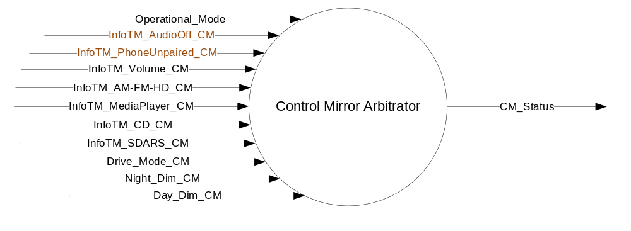

Inputs

- INTERNAL:
- Operational_Mode
- InfoTM_Volume_CM
- InfoTM_AM-FM-HD_CM
- InfoTM_MediaPlayer_CM
- InfoTM_CD_CM
- InfoTM_SDARS_CM
- Drive_Mode_CM
- Night_Dim_CM
- Day_Dim_CM
- InfoTM_AudioOff_CM
- InfoTM_PhoneUnpaired_CM

Outputs
- CM_Status, variable to identify the current Control Mirror Screen that is be requested to be displayed.

Function/Performance

Operational Modes

Mode | Differentiating Vehicle Conditions
Sleep Mode | Control Mirror Arbitrator Disabled
Limiting Mode | Control Mirror Arbitrator Disabled
Normal Mode | Control Mirror Arbitrator Enabled
Crank Mode | Control Mirror Arbitrator Enabled

Voltage Levels

Refer to the Cluster Features table located in the Operational Modes and Voltage Range Strategies STSS.

Human-Machine Interface

Visual

Indicator Graphics / Display Format
Refer to “<Program> Cluster Menu Structure.xls” and the specific Control Mirror feature STSS.

Indicator Color Coordinates

Reference Ford HMI or Studio Wallpaper files for the specific program information.

Indicator Characteristics

Reference Ford HMI or Studio Wallpaper files for the specific program information.

Audio

None

Switch Control Logic

None.

System Accuracy

Within a 100msec of receiving a message that results in a change of state the cluster will update the display to the proper status.

Operation: Performance and Functional

Subsystem Algorithm Flowchart / State Diagram
- Control Mirror Arbitrator Flowchart
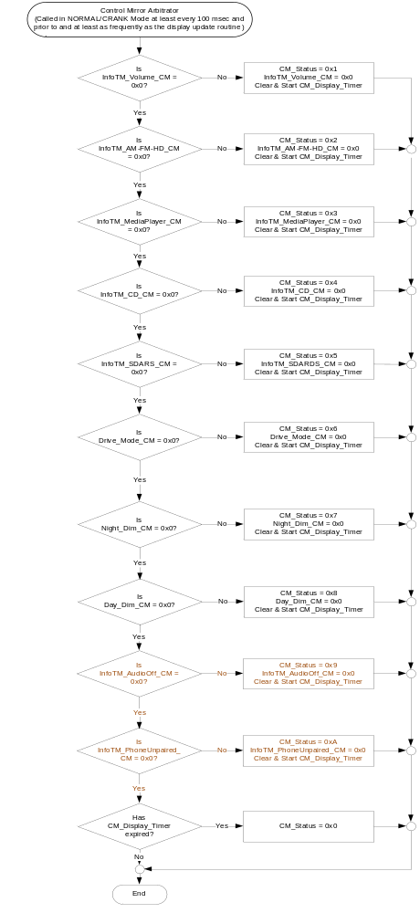

Operation Description (supports algorithm flowchart /state diagram)

The HMI logic specified in the cluster display logic STSS shall define when to trigger the appropriate control mirror popups, which should be based upon a request to be displayed.

This STSS defines the timeout of the popup and any arbitration for requesting the display of the popup, which should be based upon a change in the value of XXX_CM variables.

The cluster display logic STSS shall specify the display arbitration when an AHUD is present in the vehicle.

The program specific graphics corresponding for the XXX_CM screens and their location in the cluster shall be provided by Ford HMI or Studio and approved by the DI Application for each program.

The table below is the definition of CM_Status.

- CM_Status
CM_Status | Description
0x0 | Inactive
0x1 | Audio Volume
0x2 | AM-FM-HD
0x3 | Media Player
0x4 | CD
0x5 | SDARS
0x6 | Drive Mode
0x7 | Night Dimming
0x8 | Day Dimming
0x9 | Audio Off
0xA | Phone Unpaired
0xB | Not Used
0xC | Not Used
0xD | Not Used
0xE | Not Used
0xF | Not Used

Function Safety Classification (EMC)

Class B

Memory Storage

Parameter Name | Description | Value at  Battery Connect | Value at Module Wake-up
CM_Status | State Indicator to identify which Control Mirror is requesting to be displayed. | 0x0 (Inactive) | 0x0 (Inactive)
InfoTM_Volume_CM | Indicates the state of the Infotainment Volume Control Mirror display | 0x0 (No Display) | 0x0 (No Display)
InfoTM_AM-FM-HD_CM | Indicates the state of the Infotainment AM/FM/HD Control Mirror display | 0x0 (No Display) | 0x0 (No Display)
InfoTM_MediaPlayer_CM | Indicates the state of the Infotainment Media Player Control Mirror display | 0x0 (No Display) | 0x0 (No Display)
InfoTM_CD_CM | Indicates the state of the Infotainment CD Control Mirror display | 0x0 (No Display) | 0x0 (No Display)
InfoTM_SDARS_CM | Indicates the state of the Infotainment SDARS Control Mirror display | 0x0 (No Display) | 0x0 (No Display)
Drive_Mode_CM | Indicates the state of the Drive Mode Control Mirror display | 0x0 (Inactive) | 0x0 (Inactive)
Day_Dim_CM | Indicates the state of the Day Dim Control Mirror display | 0x0 (Inactive) | 0x0 (Inactive)
Night_Dim_CM | Indicates the state of the Night Dim Control Mirror display | 0x0 (Inactive) | 0x0 (Inactive)
InfoTM_AudioOff_CM | Indicates the state of the Infotainment Audio Off Control Mirror display | 0x0 (No Display) | 0x0 (No Display)
InfoTM_PhoneUnpaired_CM | Indicates the state of the Infotainment Phone paired status - Control Mirror display | 0x0 (No Display) | 0x0 (No Display)
Operational_Mode | 4 state indicator for cluster operational mode | Limited | Limited, Normal or Crank

Parameter Name | Description | Range | Units | Resolution | Init Value
CM_Display_Timer | Timer used to remove the CM Screen from the Display | 0 – 63 | Seconds | 0.5 | 8  (4.0 seconds)

Reconfigurable Telltale

Not Applicable

Prove Out

Not applicable

Message Center Msg

Refer to text as defined in the Text Translation file.

Error Handling

No missing message strategy defined for these input signals.

Diagnostics

Self Test

None

Engineering Test Mode

None

Part II Performance

Supported Diagnostic Trouble Codes (DTCs) - None

DID DExx - None

Reference Specification
- Appropriate Message Center Display STSS
- Appropriate Program Specific Text Translation File
- Appropriate Program Specific IPC Menu Structure File

Revision History
SPSS Module Revision History

Revision Level | Name | Change Description | Date
1.0 | T. Cwik | Initial release | 8/27/2014
1.1 | R. Chalanti | Additional Contor Mirrors requested by D544 program team to use the Audio and Phone Quick Action Menu buttons  If Audio is OFF, display a Audio_Off control Mirror  If Phone button is pressed, when phone is unpaired, display a Phone_Unpaired control Mirror | 5/29/2015

